11.20 INHERENT RISK ASSESSMENT

The following describes the functionality and features included in Probe Audit Premium+

Objective

The objective of this document is to obtain an understanding of the entity and its environment, and to identify and assess the inherent risks of material misstatement at the financial statement level.

The following key concepts of the Probe Audit Premium+ Methodology are set in this document:
- Inherent risk at financial statement level
- Identification of inherent risk factors - complexity, subjectivity, change, uncertainty, and management bias (ISA 315)
- Determination of significant classes of transactions, account balances, and disclosures (SCOTABD) that drive audit strategy

Document placement
Document 11.20 – Inherent risk assessment can be found in the Planning and risk assessment procedures folder in the Caseware document manager.
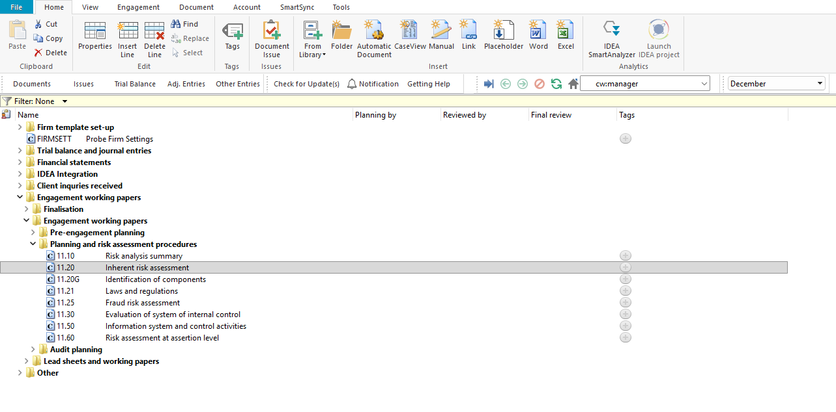

Document content
This document is designed to be a questionnaire type document with space for a comment or further description.
The document requires the engagement team to perform risk assessment procedures and document the understanding obtained about the entity and its environment. The understanding is organised across five aspects as required by ISA 315 (Revised 2019):
- Structure, ownership and governance – documents the entity’s organisational structure, ownership, governance arrangements, and related party relationships.
- Business model – documents the entity’s objectives, strategies, business operations, key management personnel, and investment activities.
- Industry, regulatory and external factors – documents industry conditions, regulatory factors, and other external factors affecting the entity.
- Measures to assess financial performance – documents the measures used by management and external parties to assess the entity’s financial performance.
- FRF and accounting policies – documents the financial reporting framework applied by the entity, accounting policies, and accounting estimates.
This document is divided into different bookmarks in the document map to assist you in identifying and assessing the inherent risks of material misstatement:
- Risk assessment procedures
- Understanding of entity and environment
- Conclusion
- Risk of material misstatement
[Screenshot: Document map]

Record inherent risk at financial statement level
Each procedure in the document includes a Risk column with a risk icon. Select the risk icon to record an inherent risk at the financial statement level.
When a risk is recorded, it will populate the inherent risk assessment at the financial statement level in question 22 and the risk tables in 12.20 – Audit plan and strategy.

Layout
Column | Input Required | Outcome
Risk assessment procedures
Type of procedures | No input is required in this column. Read the type of risk assessment procedure listed. | No impact on the engagement file.
Select | Select the risk assessment procedures performed by clicking on the tick box. | No impact on the engagement file.
Describe the source(s) from which information was obtained | Describe the source from which information was obtained for each risk assessment procedure selected. | No impact on the engagement file.
Risk | Record a risk or event by selecting the risk icon. | A risk or event will be recorded in the relevant risk table in the engagement file.
Understanding of entity and environment
Procedure | No input is required in this column. Read the procedure and consider the matters listed. | No impact on the engagement file.
Description | Provide a description of the understanding obtained for each procedure. | No impact on the engagement file.
Risk | Record a risk or event by selecting the risk icon. | A risk or event will be recorded in the relevant risk table in the engagement file.
Conclusion
Conclusion questions | Read the conclusion question. | No impact on the engagement file.
Select | Select Yes or No to the conclusion question. | No impact on the engagement file.
Description | Provide a description or explanation for the conclusion. | No impact on the engagement file.
Ref | No input is required in this column. Reference to supporting documentation. | No impact on the engagement file.
Risk of material misstatement
Risk assessment | Assess the inherent risk at the financial statement level. Consider the objectives, strategies and related business risks that may result in a risk of material misstatement of the financial statements. | The input will populate the risk tables in this document and 12.20 – Audit plan and strategy.

Document outcomes
You must complete the risk assessment procedures section to document the type of procedures performed and the sources from which information was obtained.
The understanding obtained about the entity and its environment must be documented for each procedure in the description column. Risks should be raised where appropriate by selecting the risk icon in the Risk column.
The conclusion must be completed to confirm whether the results of the procedures indicate any risks that management was expected to identify but failed to do so.
The inherent risk at financial statement level must be assessed in question 22, considering the objectives, strategies and related business risks that may result in a risk of material misstatement of the financial statements.

Group Audits
When the engagement type was selected as ‘Group Audit Single’ or ‘Group Audit Multiple’, questions are modified for the separate group audit engagement file.
Additional questions were added for group audit engagement to:
- Identify components for planning and performing of audit procedures;
- Determine expected involvement of component auditors in risk assessment procedures and further audit procedures;
- Evaluate access to components and component auditors; and
- Determine whether there is any indication that the group auditor will not be able to be sufficiently and appropriately involved in the work of the component auditor.
Some questions include red warnings or blue text in the description column. Follow the red warnings that inform you where key information should be recorded and the blue text in the description column that advises you where the understanding may be documented.

IN CONCLUSION
Features
The following features are available in the document:
- Insert or delete a comment, see page F3
- Insert or delete a row, see page F5
- Record a risk or event, see page F10
- Core vs Extended, see page F15
- Guidance, see page F16
- Freeze, see page F19

